1

Graduate Portfolio
Aditya Hede

1228940936

Dr. Tatiana Walsh Arizona State University

Table of Contents
Resume 3
Reflection 5
Overview 8
Accomplishments… 10
Accomplishment1… 10
Accomplishment2… 18
Accomplishment3… 23
References… 28

Resume

Aditya Hede

Education
Master of Science in Information Technology Graduating Spring 2025 (Information Technology Project Management)
Arizona State University, Tempe, Arizona, USA GPA: 3.78 /4

Technical Concepts

Data Visualization, Analyzing Big Data, Advanced DB Management Systems, Natural Language Processing, Advanced Information Systems Security, Advanced Big Data Analytics/AI, and AI into cybersecurity for IT.

Technical Skills

Programming : Java, Python, Shell, JavaScript.

Coding Tools : IntelliJ, MySQL, GitHub, Compass, AWS, Tableau. Web Technologies : Node.js, Angular.js, Express.js, HTML, CSS.
Cloud Technologies : Amazon Web Services, Microsoft Azure, Google Cloud Platform. Databases : SQL, MongoDB, DynamoDB.

Professional Work Experience
Technical Support Engineer – Joveo Technologies, India Nov 2021 – Apr 2022

- Created RESTful APIs with AWS serverless architecture, utilizing Node.js, AWS Lambda, and API Gateway.
- Reduced manual efforts by 75% through automation of repetitive tasks using Node.js and SQL, which improved accuracy and data integrity while minimizing manual data entry.
- Built highly scalable, low-latency, fault-tolerant, and high-performance architectural solutions for customer-facing web applications, demonstrating proficiency with DSA.
- Resolved complex functional issues within applications using Node.js, achieving maximum test coverage.
- Contributed significantly to the debugging of a web application using Node.js, RESTful APIs.

Reflection

My Graduate Experience

I concentrated on information technology during my graduate studies at Arizona State University. I was able to learn a great deal about database administration, cloud computing, and software engineering, among other aspects of IT, because to this curriculum. The projects and curriculum gave students the chance to learn and develop the fundamental abilities needed to create effective systems.
I now have a thorough understanding of enterprise-level software solutions and contemporary cloud-based architectures thanks to my emphasis on information technology. I gained a strong technical foundation that allowed me to stay up to date with industry changes and best practices while applying IT principles successfully.

Focus Area and Academic Journey

Cloud Architecture was my favorite course that I took. This course offered priceless knowledge about developing, deploying, and refining cloud-based systems. It provided a practical way to interact with cloud infrastructure, which improved my knowledge of service management. My confidence in designing dependable and scalable cloud systems increased as a result of the course's ability to apply theoretical knowledge to real-world applications. My enthusiasm for cloud computing was stoked by the focus on practical applications and critical thinking, which equipped me for the demands of these professions.

Academic Accomplishments

Achieving a GPA of 3.96 during my graduate studies was one of my major academic achievements. This accomplishment demonstrates my devotion to both academic brilliance and material mastery. It took a disciplined approach to juggling assignments, projects, and extra learning activities in order to maintain a high GPA.

Completing many cloud computing and big data initiatives is another noteworthy achievement. Through these initiatives, I was able to have practical expertise in working with big datasets and developing scalable cloud solutions. I improved my technical knowledge and problem-solving skills through these experiences, equipping me to face problems in the industry.

Post-Graduation Aspirations:

I'm applying right now for a job as a software development engineer. I believe I'm a good fit for this position because I have five years of expertise creating scalable software solutions and maximizing performance. My practical knowledge of cloud technologies and my technical expertise in languages like Java, Spring Boot, and JavaScript meet the criteria of this role.

I want to use my experience with automation, cloud architecture, and agile approaches in this position to help create software that is of a high caliber. My background in performance optimization, debugging, and teamwork has given me the abilities I need to succeed in this role.

Joining the Alumni Network:

Yes, please add me to the alumni group for information technology. I would be able to stay up to date on industry advancements and other experts by joining this club, which would also offer beneficial networking chances. After graduation, I'm excited to interact with other graduates and

give back to the community. To add me to the group or for any other correspondence, please contact me at anandakella777@gmail.com.

Overview
My two years at Arizona State University were filled with important projects, which are showcased in my graduation portfolio. Being a part of an organization of this caliber makes me very proud. This portfolio includes three significant projects that demonstrate my development and accomplishments. I want to work as a Software Development Engineer (SDE), and these projects and my coursework have given me important knowledge about software development, which has strengthened my resolve to pursue this career path.

IFT 530: Advanced Database Management System - University Database Management

To effectively store and manage academic records, including those of students, instructors, courses, and enrollments, this project concentrated on creating a university database management system. Normalization, indexing, and relational constraints were used in the SQL database design process to guarantee data integrity. Retrieving student and teacher information, controlling course offers, and monitoring enrollments were among the primary features. By facilitating effective data organization and retrieval via structured queries, the system offered insightful information on academic operations. This project was a useful application of sophisticated database principles that improved our comprehension of relational data modeling, query optimization, and database design.

IFT 533: Data Visualization – Employee Data Visualization and Reporting.

To investigate important topics including employee performance, turnover rates, demographic diversity, and termination trends, the team used Tableau to create dynamic visualizations, such as bar charts, pie charts, and heatmaps. Data accuracy was guaranteed by pre-processing procedures such normalization, duplicate elimination, and addressing missing data. The dashboard offers actionable insights into diversity, recruiting, and retention programs, which benefit a wide range of

users, including senior executives, workforce analysts, and HR managers. Hover tooltips, filters, and sorting are examples of interactive features that improve user personalization and engagement. Pay zone differences, demographic breakdowns, and relationships between tenure and performance are some of the important issues discussed. The visualizations help data-driven decision-making by highlighting ethnic diversity, gender distribution across pay zones, and departmental performance. The project aligns HR practices with company objectives by emphasizing equity, diversity, and strategic workforce planning. Citations to Tableau documentation and Kaggle datasets highlight the project's strong technology and methodology foundation. All things considered, the dashboard is a complete tool for improving workforce management and cultivating an organizational culture that is focused on data.

IFT 511: Analyzing Big Data – Credit Risk Classification with Decision Tree Modeling

The project's main goal is to forecast Phoenix, Arizona kids' average math performance by analyzing the variables that affect academic success using a regression model. After gathering information from 115 high schools, including details like overall enrollment, graduation rates, and minority enrollment, the team thoroughly cleaned the data by eliminating unnecessary columns and dealing with missing numbers. Using Min-Max scaling to normalize numerical characteristics and transforming percentage-based metrics, such as graduation rates, into float values, were two important changes. Pair plots were used to illustrate the patterns and correlations between variables that were found through exploratory data analysis (EDA). Evaluation metrics including an MSE of 0.056, an RMSE of 0.237, and an R2 score of 0.152 were obtained after a linear regression model was trained on 55% of the data and tested on the remaining 45%. The findings showed that while minority enrollment had a negative correlation with math scores, greater graduation rates had a favorable correlation. Teachers and legislators can create focused interventions to raise math competency with the model's insights. All things considered; it offers a basis for comprehending the main elements influencing student achievement in Phoenix schools.

Accomplishments Accomplishment 1 - (IFT 530 - Advanced Database Management Systems) Project Title: University Database Management

Purpose:

The project shows how a relational database system for a university is designed, implemented, and maintained. Among the main goals were:
constructing tables for students, instructors, departments, courses, enrollments, and course offerings in a normalized database schema.
putting in place limitations (unique fields, foreign keys, and main keys) to guarantee data integrity.
putting example data into tables to mimic actual academic processes.
To improve functionality, create user-defined functions (UDFs), triggers, stored procedures, views, and SQL queries.
utilizing an audit table and triggers to audit database modifications.

Importance:

Maintaining a soccer database is essential for several key reasons:

Historical Insights and Trend Analysis
Tracking and analyzing historical data is a major advantage of keeping a soccer database. The database provides insightful information about historical patterns, accomplishments, and performances—all of which are essential for comprehending how teams and players have changed

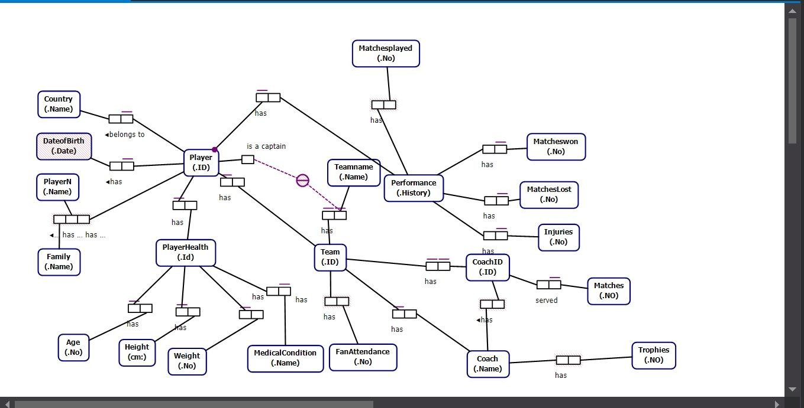

Our soccer database's project management tool includes a number of entities, such as players, teams, coaches, and performance indicators. Specific properties describe each entity:
- Player: This part contains attributes like nation, team affiliation, first and last names, and player ID. Teams and players continue to have a many-to-one relationship.
- Team: The team ID, name, coach, nation, and attendance statistics of the fans are among the attributes for this entity.
- Coach: Coach ID, full name, team affiliation, age, number of awards won, and matches coached make up this entity.
- Performance: This keeps tabs on player performance indicators, such as the quantity of games played and victories.
- Player Health: Medical conditions and other health-related features are included in this entity.

Relational Database Diagram:
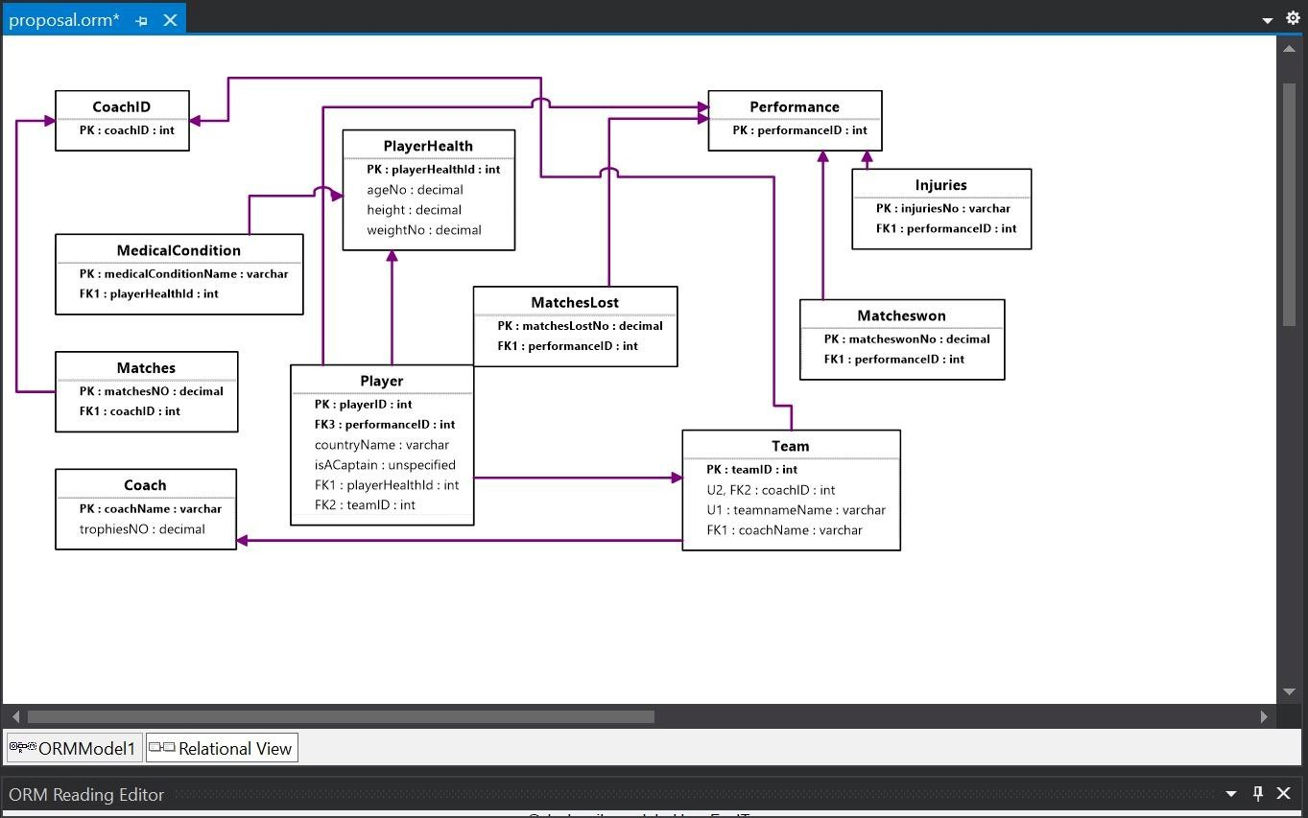

Several tables connected by the primary and foreign keys make up the relational structure:

  - Player Table: Contains player data, with player ID serving as the primary key.

  - Team Table: Includes information on teams, with the team ID serving as the main key.

  - Coach Table: Holds coach-related data, with coach ID acting as the main key.

  - Performance Table: keeps track of player performance metrics.

  - Player Health Table: keeps track of players' health information.

SQL Implementation

SQL Server Management Studio was used to create the database:
  - Tables with the required constraints were created for every entity.

  - To extract certain insights, like identifying top-performing players or figuring out which teams had the most fans, SQL queries were created.

  - To automate changes and preserve data integrity, triggers and stored procedures were used.

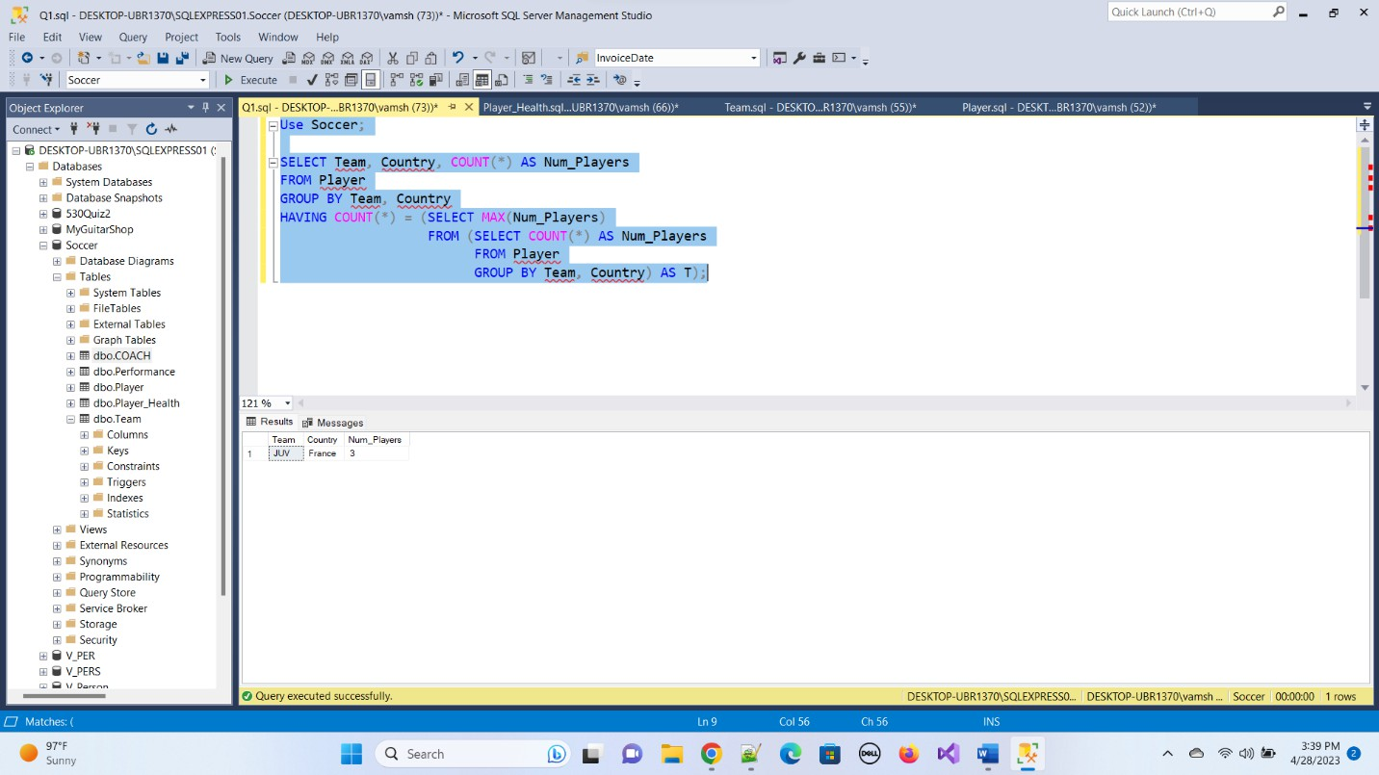

  - 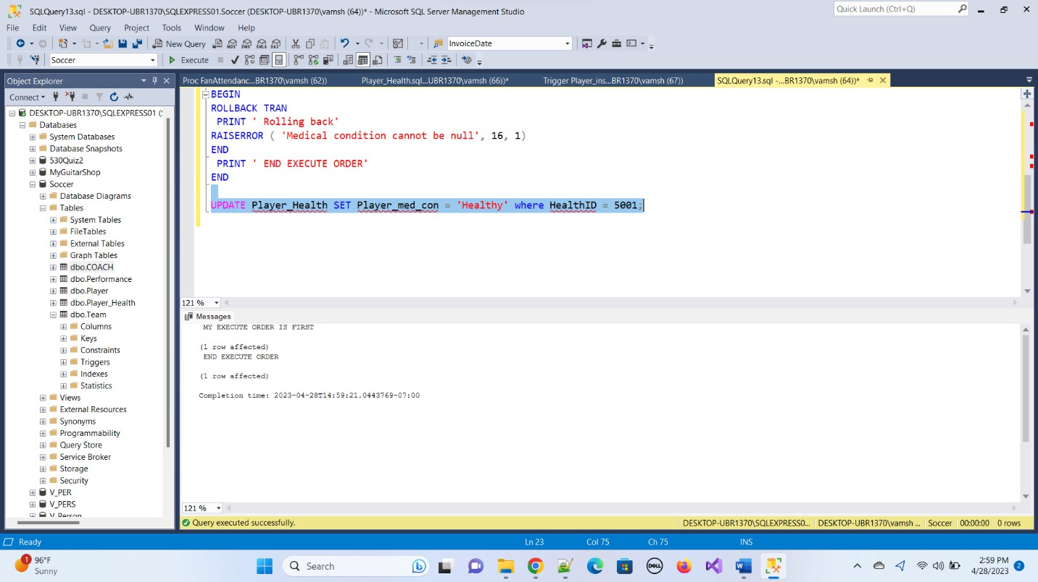

NoSQL Implementation

Additionally, a Couchbase NoSQL database was created:
    - Buckets were setup for entities such as players and teams.

    - Data was indexed to facilitate efficient querying using SQL++.
    - Without the limitations of a set schema, flexible data management was made possible by the NoSQL architecture.

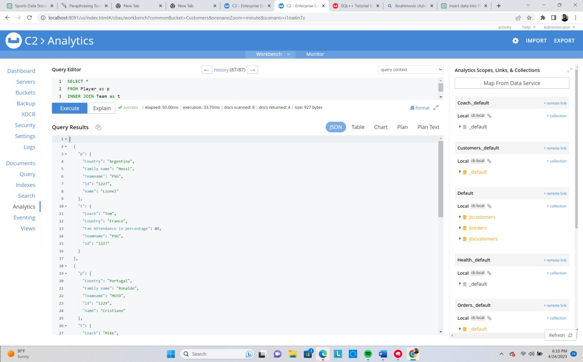

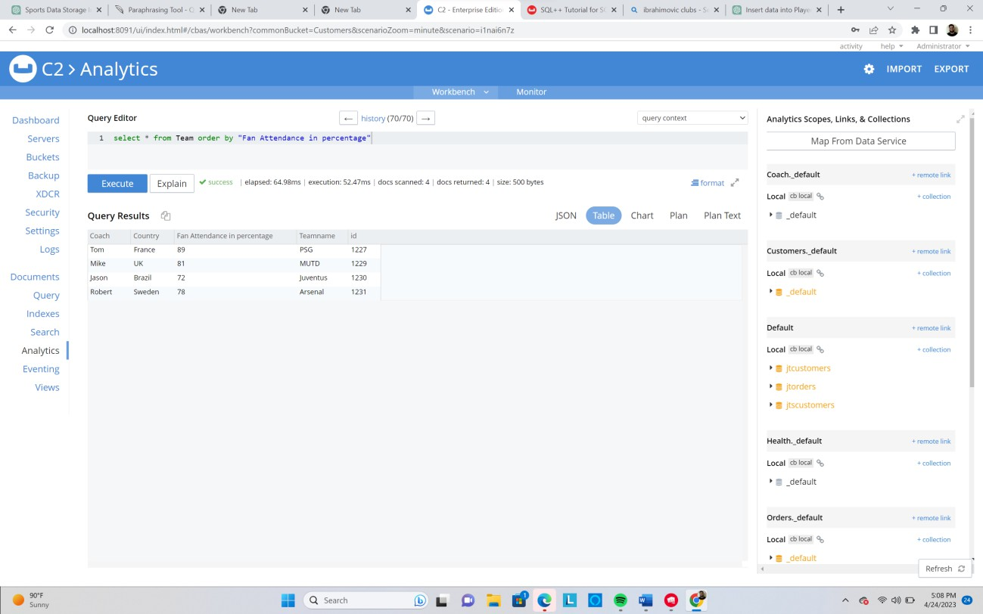

Summary

This project demonstrated how well SQL and NoSQL databases can be integrated to manage data pertaining to soccer. While the NoSQL database offered the flexibility required to handle unstructured data, the SQL database made structured data storage easier with pre-established schemas. In-depth data analysis was made possible by this combination, enabling more dynamic queries and real-time insights. Consequently, it improved sports organizations' ability to make decisions and provided a scalable system to handle future data growth and evolving analytics requirements.

Accomplishment 2 - (IFT 533: Data Visualization and Reporting for IT) Project Title: Healthcare Analytics Dashboard for Patient Insights Introduction
A comprehensive tool for visualizing patient health data, medical conditions, doctor visits, and insurance information is the Healthcare Dashboard. By offering a comprehensive perspective of important healthcare metrics through interactive visualizations, it seeks to support healthcare professionals in making data-driven decisions.

Dashboard Overview

The dashboard incorporates a number of plots that let users examine insights like:

- Distribution of ages by medical conditions

- Top physicians according to patient visits
- Prevalence of medical conditions by gender

- Trends in insurance coverage and admissions over time

The dashboard's intuitive design facilitates interaction and allows for smooth transitions between various visual components. This flexibility enables researchers, analysts, and healthcare administrators to improve patient care and extract useful insights.

Dataset Details:

Rich patient-specific data, such as demographics, medical history, treatment specifics, and billing amounts, are included in the healthcare dataset. Important characteristics include:
- Age: Constant numbers
- Gender: Representation in categories

- Doctor: Health care providers' names
- Names of insurance companies that offer insurance

- Medical Condition: Summaries of the health conditions of the patients
In-depth investigation of patient journeys and healthcare trends is supported by the inclusion of temporal data on admission and discharge dates, which enhances the dataset.

Key Insights and Visualizations:

The control panel makes it possible to investigate important queries, such as:

- Distribution of ages by medical conditions

- Changes in test results over time for particular conditions

- Comparisons of medication frequency for different medical conditions
- Annual trends in admissions

- An examination of insurance companies' finances

Visualizations include:

  - Line graphs that display admissions over a six-year period

  - Bar charts: comparing the distribution of ages by type of admission

  - Pie charts: Showing the distribution of blood groups for particular conditions

  - Comparing the expenditures of insurance providers using stacked bar graphs

Interactivity Features:

Customized analyses are made possible by interactive controls that let users filter data by medical conditions. Deeper insights into particular patient demographics and healthcare trends are made possible by this functionality, which improves the user experience.

Final Dashboard:

Click on link below to access the public dashboard. For healthcare administrators and analysts, the dashboard is an effective tool that supports strategic decision-making and raises the standard of healthcare services.
https://public.tableau.com/app/profile/sai.manoj.vissavajhula/viz/Final-DV-HC-
533/Dashboard1?publish=yes

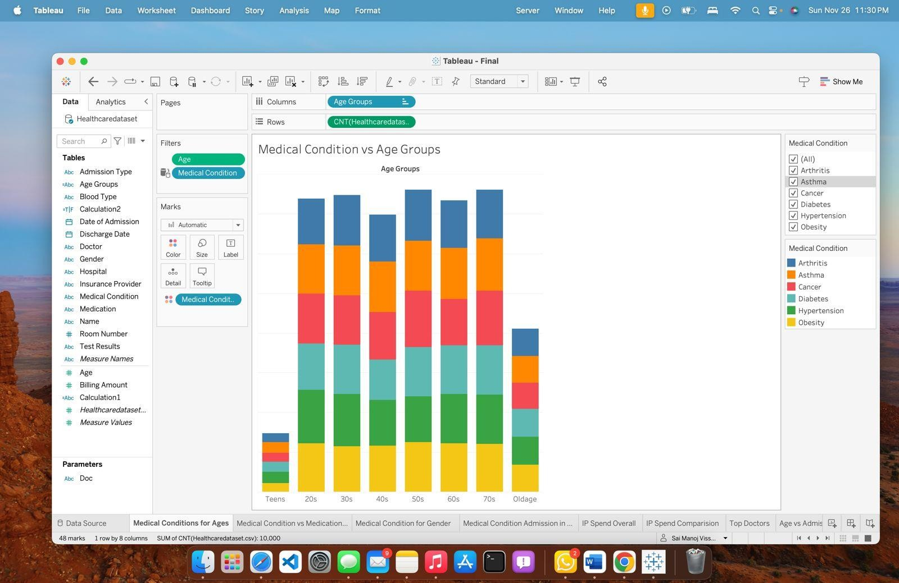
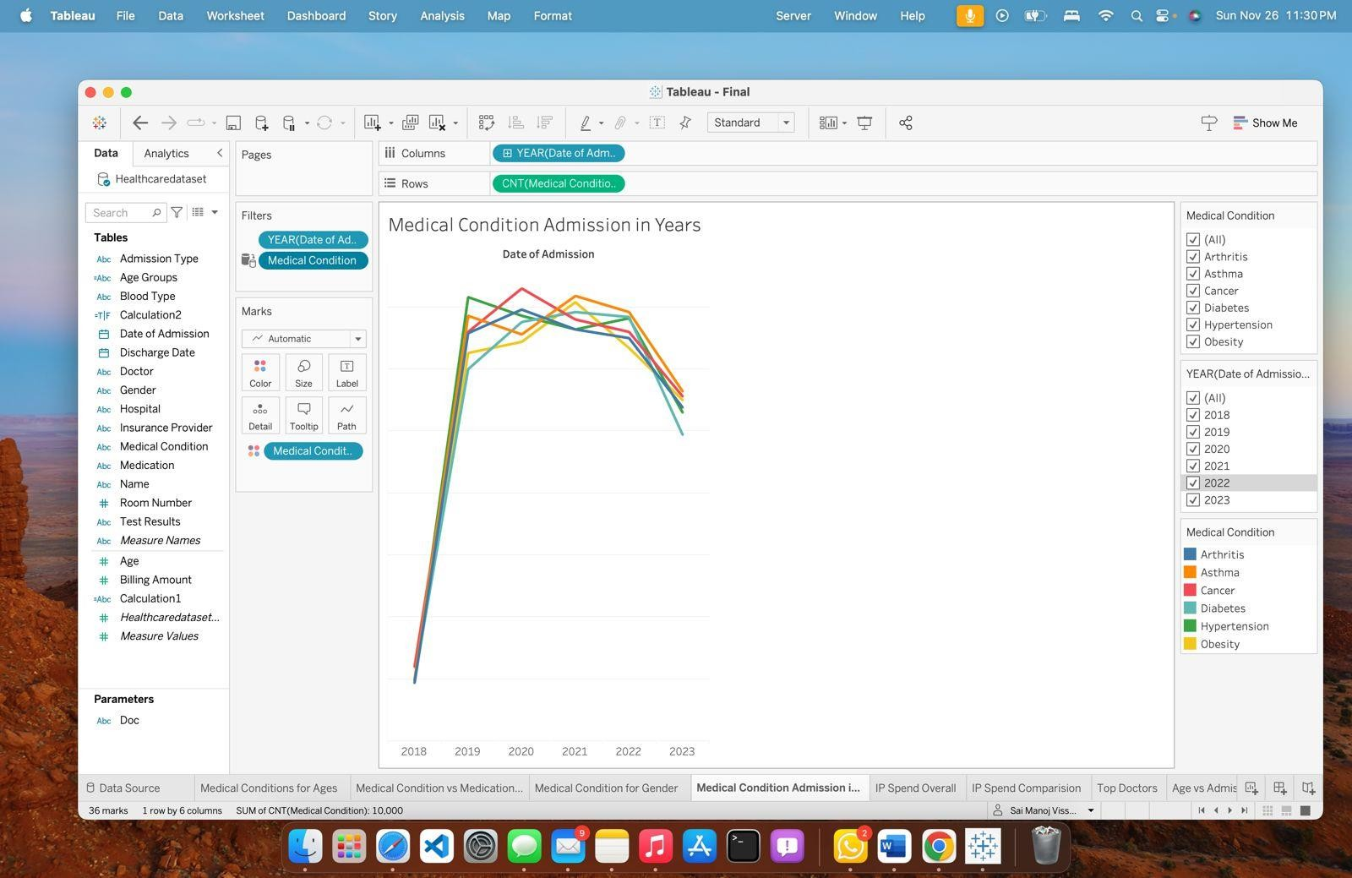

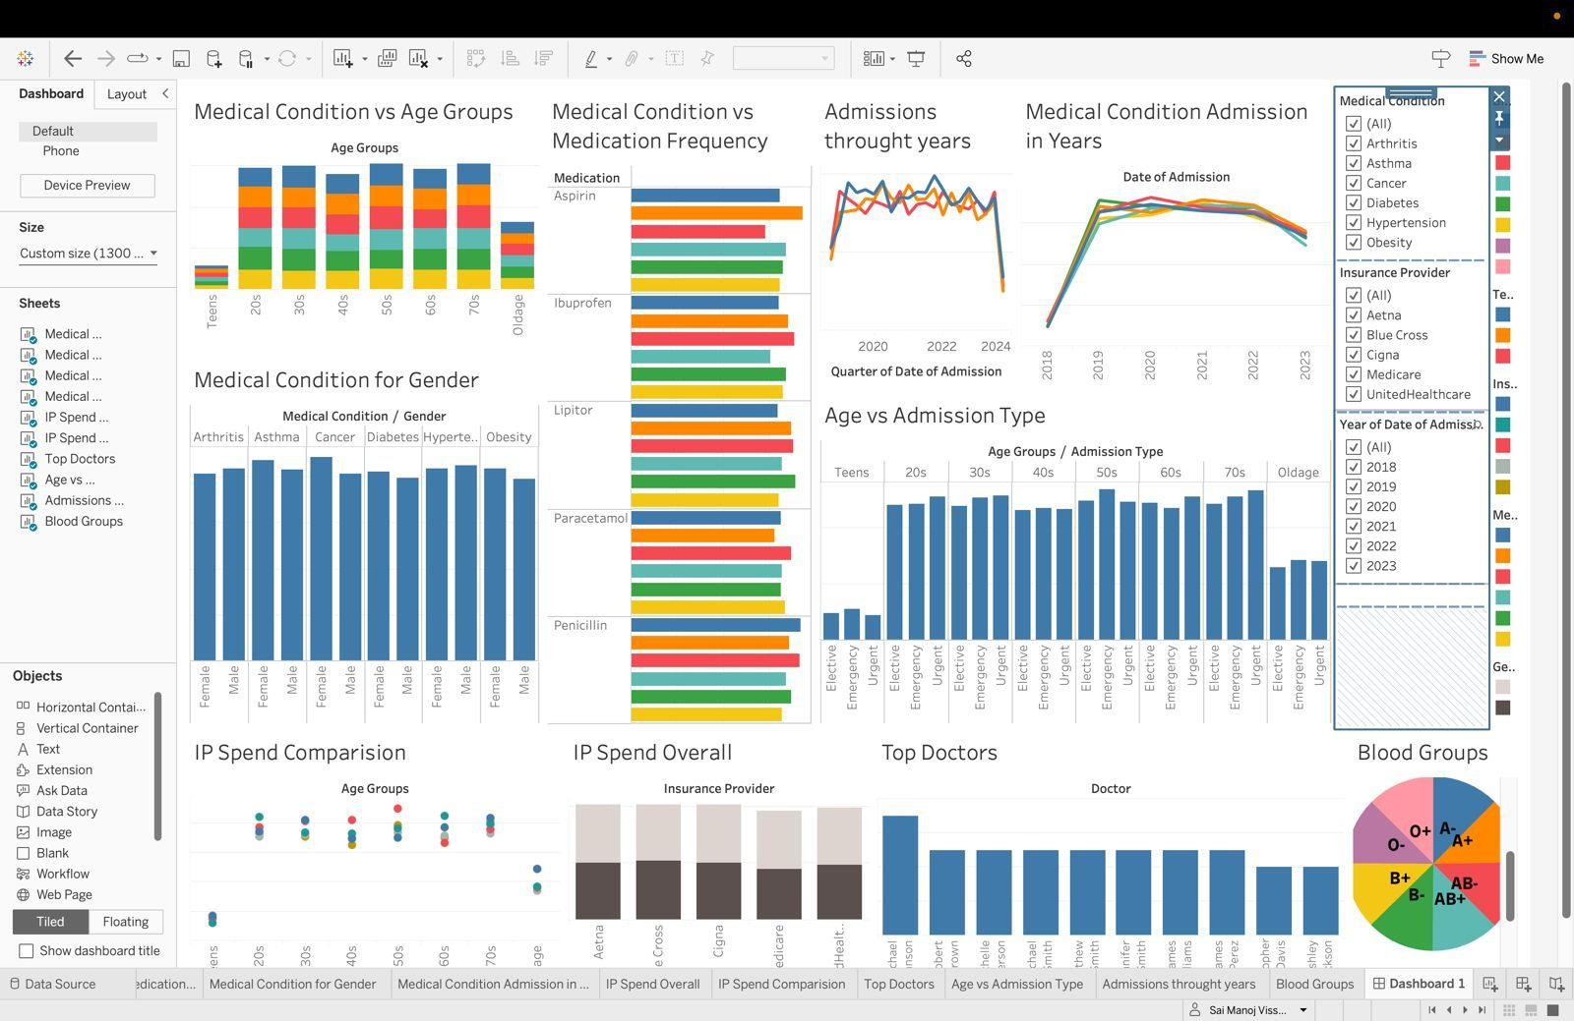
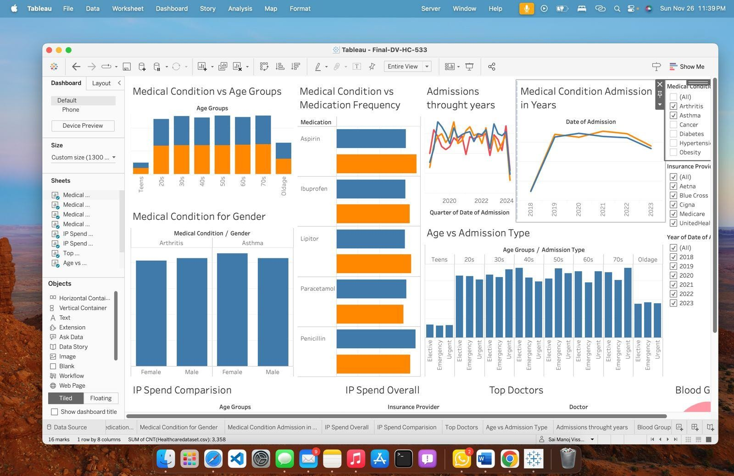

Summary

The goal of the Healthcare Dashboard project is to give users a thorough visual depiction of healthcare data so they can extract useful information about insurance coverage, doctor visits, medical conditions, and patient health. This interactive dashboard, which was created as a component of the IFT 533 course under the direction of Dr. Asmaa Elbadrawy, combines a number of plots and metrics to enable dynamic investigation of important healthcare issues.
The dashboard answers important questions like how age groups are distributed across medical conditions, how effective various medications are, and trends in hospital admissions over time by using a rich dataset that includes patient demographics, medical histories, and billing information. Pie charts, line graphs, and bar charts are important visualizations that are made for easy navigation and interaction.
The project gives healthcare administrators, analysts, and researchers the tools they need to improve patient care, make better decisions, and pinpoint areas that need more research. In the end, the Healthcare Dashboard is an invaluable tool for comprehending healthcare patterns and enhancing the provision of services in medical environments.

Accomplishment 3 - (IFT 511: Analyzing Big Data)

Project Title: Clustering Phoenix Schools for Improved Equity and Resource Allocation Overview
The goal of this project is to use the Credit Card Default dataset from the UCI Machine Learning Repository to examine and forecast the risk of credit card default by utilizing machine learning techniques. The dataset, which includes a variety of characteristics like credit limits, payment histories, and demographic data, documents the financial activity of Taiwanese credit card users between April and September 2005. In order to help financial institutions make data-driven decisions that improve their lending processes and risk management strategies, this project uses sophisticated analytical techniques to find trends that increase credit risk.

The goal of our team is to create a prediction model that correctly categorizes credit card users according to their propensity to miss payments. We seek to offer practical insights that might help financial institutions customize their credit offerings and enhance their overall risk assessment procedures by identifying the major drivers of credit risk. By improving knowledge of consumer profiles and behaviors, this effort not only attempts to reduce monetary losses brought on by defaults but also encourages responsible lending.

Data Acquisition and Preparation
The Credit Card Default dataset was sourced and prepared for in-depth analysis as part of the data collecting process. A thorough data cleaning procedure was part of this process, where rows and columns with missing values were either removed or addressed using imputation techniques.
Numerical features were standardized to guarantee consistency in scaling, and categorical attributes were encoded to aid machine learning procedures. To preserve the integrity of the dataset, outliers were found and handled, and duplicate items were removed to avoid model bias. The dataset was structured and prepared for efficient analysis and modeling thanks to these

painstaking preprocessing procedures.

Modeling Approaches and Implementation

A variety of machine learning methods, such as Decision Trees, Random Forests, and Gradient Boosting Machines, were used to forecast credit card defaults. Because it made the decision-making process interpretable, the Decision Tree classifier was very important. By carefully adjusting variables like maximum depth and impurity criteria, we were able to ensure robust performance by optimizing the models' hyperparameters using approaches like GridSearchCV. In order to verify model performance and guarantee that the outcomes were trustworthy across various data subsets, stratified K-Fold cross-validation was employed.

Evaluation Metrics and Insights

Metrics that offer a thorough understanding of the predictive power of each machine learning model, including accuracy, precision, recall, and F1-score, were used to evaluate each model's performance. If appropriate, the silhouette score was also used to assess the clustering's quality. In terms of prediction accuracy and robustness, a comparison analysis revealed that the Random Forest model performed better than the Decision Tree and Gradient Boosting models. This research highlights how machine learning may improve credit risk assessment and give financial organizations useful information to better customer relationship management and risk management tactics. Organizations can use these findings to design educational initiatives that encourage financial responsibility and to establish focused interventions for at-risk clients.

Snapshots:

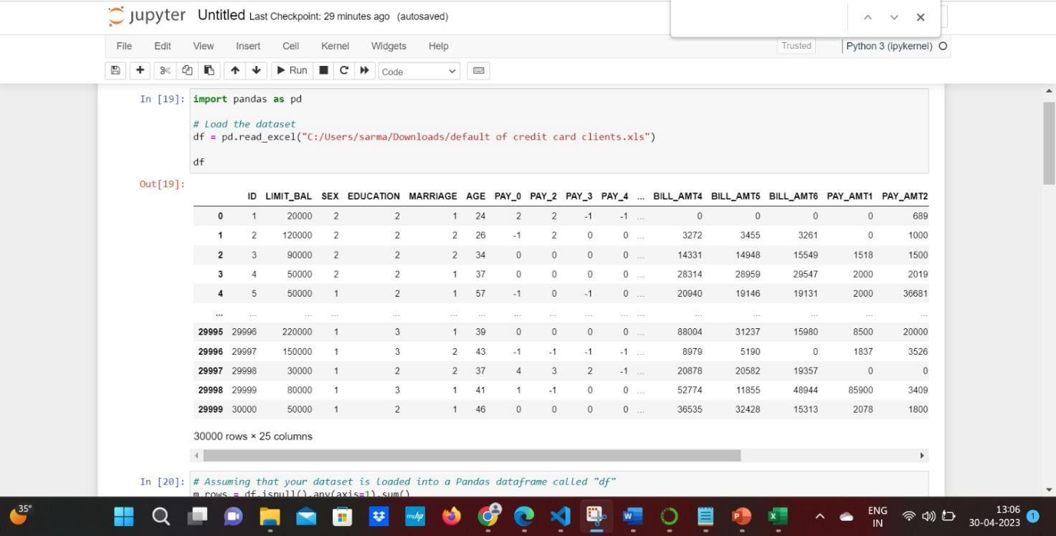



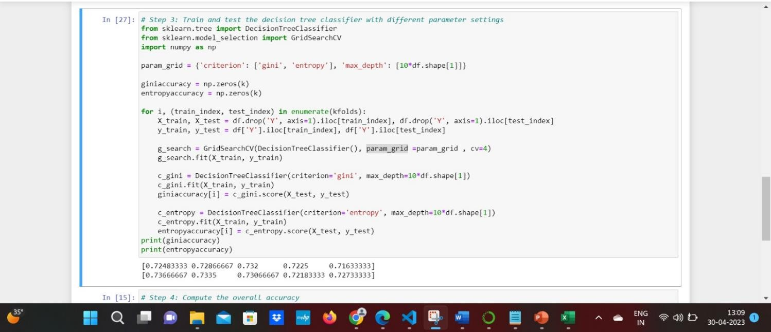

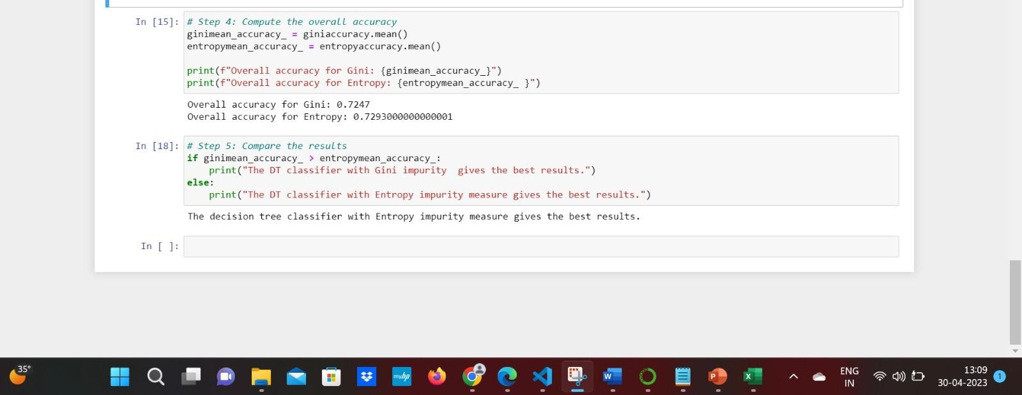
Summary:

By using machine learning techniques on the Credit Card Default dataset from the UCI Machine Learning Repository, this research aims to improve credit risk assessment. Credit limits, payment histories, and demographic information are among the features included in the dataset, which covers Taiwanese credit card customers from April to September 2005. The dataset was prepared for analysis by carefully cleaning and preprocessing it, guaranteeing its structure and dependability.
The probability of credit card defaults was predicted using a number of machine learning methods, such as Decision Trees, Random Forests, and Gradient Boosting Machines. GridSearchCV was used for hyperparameter optimization, and stratified K-Fold cross-validation was used to verify model performance. According to the findings, the Random Forest model fared better than the

others in terms of robustness and prediction accuracy.

In the end, this project shows how machine learning may improve credit risk assessment and give financial institutions useful information to improve their risk management plans. The approach promotes responsible lending practices by identifying important determinants of credit risk, which enables better informed lending decisions and focused interventions for at-risk clients.

References
Halpin, Terry. Object-Role Modeling Fundamentals: A Practical guide to data modeling with ORM. Technics Publications, 2015
Syverson, B., & Murach, J. (2012b). Murach’s SQL Server 2012 for Developers (Training & Reference) (1st ed.). Mike Murach & Associates
Couchbase Product Marketing. (n.d.). The Couchbase Blog. The Couchbase Blog. https://blog.couchbase.com/
SQL++ For SQL Users: A Tutorial by Don Chamberlin Copyright © September 2018 by Couchbase, Inc.
Healthcare Dataset. (2024, May 8). Kaggle. https://www.kaggle.com/datasets/prasad22/healthcare-dataset
Public Dashboard Link. https://public.tableau.com/app/profile/sai.manoj.vissavajhula/viz/Final-DV-HC-
533/Dashboard1?publish=yes

Provost, F., & Fawcett, T. (2013). Data Science for Business: What You Need to Know about Data Mining and Data-Analytic Thinking. https://dl.acm.org/citation.cfm?id=2564781
UCI Machine Learning Repository. (n.d.).

https://archive.ics.uci.edu/dataset/350/default+of+credit+card+clients

Mishra, S. (2024, August 18). Unsupervised learning and data clustering - towards data science.
Medium. https://towardsdatascience.com/unsupervised-learning-and-data-clustering-
eeecb78b422a

Jain, A. K. (n.d.). Cluster Analysis: basic concepts and algorithms. In Chapter 8 (pp. 488–490). https://www-users.cse.umn.edu/~kumar001/dmbook/ch8.pdf

